JAVA

https://www.youtube.com/watch?v=LkcYS0SD5x8&index=1&list=PLltsQb0J9n8vN0sTuxhjWHKL4Wf-OERTU

UNSORTED

comprehensive exercize
int[] a1 = {10,20,30,40,50};
int[] a2 = new int[5];
System.arraycopy(a1, 0, a2, 0, 5); //can copy same types only

Integer[] a3 = new Integer[5];
for(int i=0; i<a3.length; i++){a3[i]=a2[i];} //workaround to copy an array

List<Integer> l = new ArrayList<>();
for(Integer I:a3){l.add(I);}

Map<Integer,Float> m = new HashMap<>();

Iterator<Integer> it = l.iterator();

while(it.hasNext()){
int n = it.next();
Float f = (float)n;
m.put(n,f);
f = m.get(n);
System.out.println(f);}

boolean b = it.hasNext(); //false

System.out.println(l);
System.out.println(m);

String is immutable
String S1 = "Original", S2;
S2 = S1;
S1 += "New";
boolean b = S1.equals(S2); //false

between char[] and String
String S = "String";
S = new String("String") + S; #same effect

char c = S.substring(5).toCharArray()[0];
char[] a = {'S','t','r','i','n', c};
S = new String(a); #same effect
a = S.toCharArray();

static roughly means __ini__ (?)
static method = class method
non-static method = instance method

CONSTANTS
package code;

public class Main {
public static final String NAME = "Constant";

public static void main(String[] args){
final int CONSTANT = 999;
System.out.println(NAME + CONSTANT);
}//main
//define methods here..
}//Main

garbage collection
int i = 888; // cannot be set to null because primitive
Integer Int = 999;
Int = null; // will be garbage-collected
System.gc();

static vs non-static methods
public class Klass{

public static int func(int arg){ //static methods are "class functions"
int result = arg*2;
return result;
}

protected int method(int arg){ //non-static methods are "instance methods"
int result = arg * 3;
return(result);
}
}

public class Main {
public static void main(String[] args){

int i = Klass.func(123);

Klass ins = new Klass();
i = ins.method(234);
}//Define your methods here..
}

RUNNING JAVA

Change the drive in the Command Line
d:
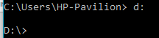

Compile java
javac Main.java

Passing the user’s arguments
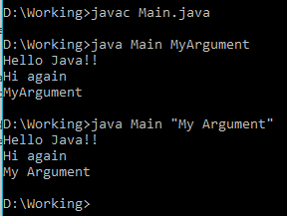

Packages
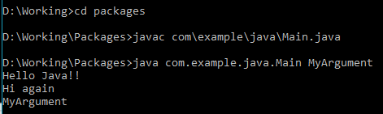

private static double
public class Main {
public static void main(String[] args){
String s = new String("-.950");
double d = function(s);
Double D = function(s);
d += D;
D++;
System.out.println("d=" + d + "\nD=" + D);

}
//DEFINE FUNCTIONS HERE (at the end of the Main class, after the main method)
private static double function(String arg){
double d = Double.parseDouble(arg);
return d;
}
}

public class Main{
public static void main(String[] args){
System.out.println("before the return");
return;
// nothing will be executed after the return
}//main
//define methods here
private static double function(String arg1, String arg2, String op){
return(.5);
return new Double(1.5);
}
}//Main

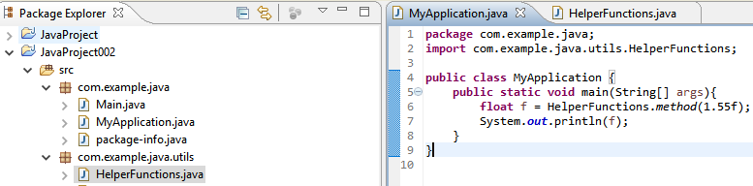
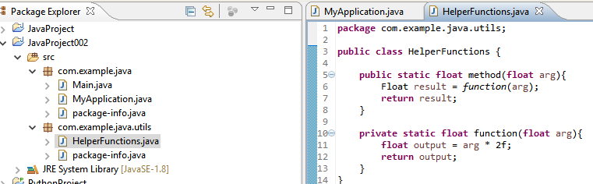
package structure

running a Java class
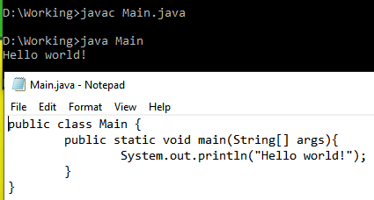

passing arguments
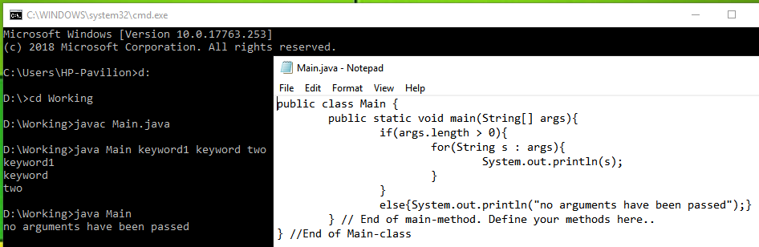

protected methods
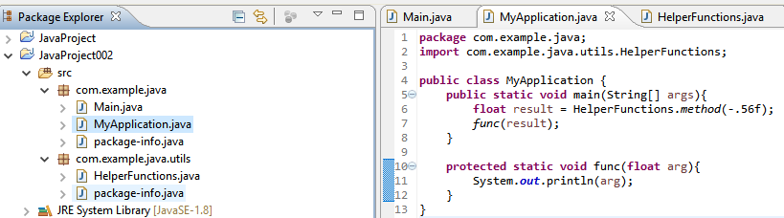

CLASS

creating a Class in Java
(this is Main.java)
public class Main {
public static void main(String[] args){
Klass ins = new Klass();
System.out.println(ins); System.out.println(ins.attribute);

ins.status = !ins.status;
ins.method();

Integer I = ins.calculate(3.f);
System.out.println(I);
}//main
//define methods here..
}//Main
(this is Klass.java)
public class Klass{
public String attribute;
public boolean status = true;

public void method(){
System.out.println(this.status);
}

public int calculate(float arg){
double result = this.func((double)arg, (byte)2);
return (int)result;
}

private double func(double arg1, byte arg2){
double result = Math.pow(arg1, arg2);
return result;
}
}

SYNTAX

public class Main{public static void main(String[] args){System.out.println(args.length);}}

public class Main {
public static void main(String[] args) {
int i = 12345;
int k; k = 999;
System.out.println(i+k);
} //END OF public static void main
} // END OF public class Main

long i = 0L;
i = i + 1;
i += 1;
i++;
i--;

if statement
if(b<0){b=127; b--;}
if (true){b = 127; b--;}

java.lang.Math.round
double d = (double) Byte.MAX_VALUE;
d++;
d+=.9999f;

long l = Math.round(d);
l += java.lang.Math.round((float) d);

byte b = (byte) (l - 2L);
b -= (byte) Math.round(new Double(d).floatValue());

data types
byte b; short s; int i; long l; float f; double d;
b = (byte)Math.abs(-128);
i = Math.abs(-128);
l = Math.abs(-128L);
f = Math.abs(-128.f);
d = Math.abs(-128.d);

b = (byte) Math.round(new Double(Math.abs(-128.1d)).floatValue());

Math class
https://docs.oracle.com/javase/8/docs/api/java/lang/Math.html

the Math module
long l; double d = -.5d;
l = Math.addExact((byte)1.5f, (int) 200L); //201
d = Math.ceil((double)1.3f); //2.0
d = Math.cos(Math.toRadians(45d));

boolean syntax
boolean b1, b2 = true;
b1 = false;
boolean b = b1 | b2; // =true
b = b1 & b2; // =false
if (b != true){b1 = !b2;};
System.out.println(""+b1+b2);

declaring static variables
public class Main {
static boolean b; //false
static double d;
static float f;
static long l;

public static void main(String[] args) {
boolean b1 = !b; //now b1 = true
l = l + l;
l = (long) (f * d);
f = Math.abs(l);
d = Math.round(d);

System.out.println("" + b1 + "\t" + d + "\t" + f + "\t" + l);
}
}

public class Main {

static boolean b; //false
static double d;
static float f;
static long l;

public static void main(String[] args) {

b = true | false; //true
b = false || true; //true
b = true & true; //true
b = true && false; //false
b = !b;

if ((b == true) & (b != false) && (f == l)){d = -.5d;};
d = Math.round(Math.abs(d));

System.out.println(new Double(d).floatValue());
}
}

b = (i > 0) & (i != 0) & !(i != Integer.MAX_VALUE) & (i == new Double(i) | !false);

boolean
boolean b = Boolean.parseBoolean("true");
Boolean B = !b;
B = new Boolean(!b);
String S = B.toString(); //"false"

b = B != b; //true
b = b & B; //false
B = b | !B; //true

char, String
char c; String S;
c = '\u0061'; //same as..
c = 'a';
S = "a";
S += c;
S = S.toUpperCase();

char c = '\u0061'; //'a'
c = Character.toUpperCase(c); //'A'
String S = Character.toString(c); //"A"
S += c; //"AA"
S = S.toLowerCase(); //"aa"
S = c + S; //"Aaa"

int n = 11;
int q = n / 4; // 2 (quotient)
int r = n % 4; // 3 (remainder)

first assign and then increment
byte b = (byte) 0L; short s;
s = b ++; //first assign the current value of b to s and then increment b by one
s = ++ b; //first increment b by one and then assign the result to s

b = (127L == 127d) & (127.d == 127f) && (127 == (byte)127.01f); //true

Float F1, F2 = 1.5f;
F1 = F2 --; // F1=1.5 F2=0.5
F1 = ++ F2; // F1=1.5 F2=1.5

F1++; // F2==1.5
boolean b = F1 == ++F2; //false because not the same object
b = (F1).equals(F2); //true

F1 = F2;
b = F1 == F2; //true because now points to the same object

String S = null;
boolean b = true;
short s = Short.MAX_VALUE;
int i = Integer.MAX_VALUE - 1;
long l = 10_000_000L;
float f = l;
Float F = new Float((float) i);

S = Boolean.toString(b);
S = Short.toString(s);
S = Integer.toBinaryString(i);
S = Float.toHexString(f);
S = Float.toString(F);

Scanner
import java.util.Scanner;

public class Main {
public static void main(String[] args) {
System.out.print("Enter text: ");
Scanner SC = new Scanner(System.in);
String S = SC.nextLine();
S = S + SC.nextLine();
SC.close();
S = "Your text is: " + S.toUpperCase();
System.out.println(S);
}
}

StringBuilder
String S = "Xyz";

StringBuilder SB = new StringBuilder("Abc")
.append(S + S.toUpperCase())
.append("\n");

SB.append("new line");

SB.delete(0, 2);
int i = SB.length();

comprehensive exercise
import java.util.Scanner;
public class Main {
public static void main(String[] args) {

StringBuilder SB; Scanner SC; String S;
SB = new StringBuilder();
SC = new Scanner(System.in);

for (int i = 1; i <= 3; i++){
System.out.print("input "+i+": ");
S = SC.nextLine();
SB.append(S + ",\t");
};
SC.close();
SB.delete(SB.length()-2, SB.length()); //deletes ",\t" (2 characters)
System.out.println(SB.toString() + "\nDONE!");
}
}

comparing
char c1, c2='ß';
c1 = 'ß';
boolean b = c1==c2;

String S1, S2 = "Äbc";
S1 = "Äbc"; //comparison = true
S1 = new String("Äbc"); //comparison = false
b = S1==S2; //doesn't always work

b = S1.equals(S2); //comparison = true

null
public class Main {
static String S;
static Boolean B;
static Double D;

public static void main(String[] args) {

System.out.println(S+B+D); //nullnullnull

S = "true";
B = Boolean.parseBoolean(S);
D = new Double("-.5f");
System.out.println(S + B + D);

S = null;
B = null;
D = null;
System.out.println(S+B+D); //nullnullnull

}
}

chaining methods together
import java.math.BigDecimal;

public class Main {
public static void main(String[] args) {
double d = 0.012;
java.math.BigDecimal BD;

BD = new java.math.BigDecimal(Double.toString(d));
d = BD.add(new BigDecimal("-12345.756")).divide(BD).floatValue();
String S = BD.add(new BigDecimal("-12345.756")).divide(BD).toString();
System.out.println(S + "\t" + d);
}
}

DATA TYPES

Numeric Primitive Data Types
byte b = (byte)-128;
short s = (short)-32_768;
int i = (int)-2_147_483_648;
long l = -2_000_000_000L;
float f = -1.57E-3f;
double d = -1.57E-3d;

Numeric Primitive Data Types
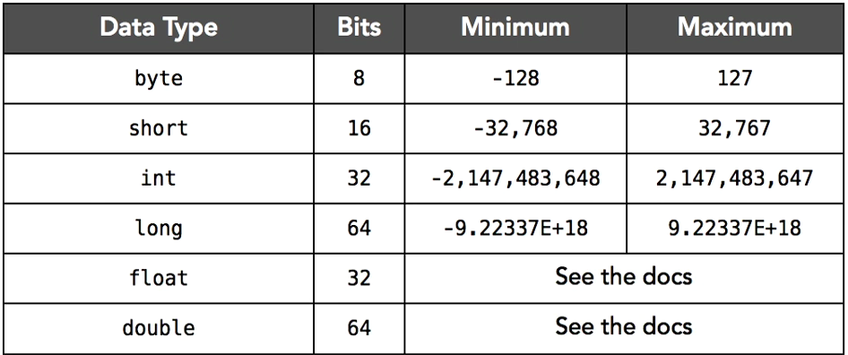

Primitives vs Objects (i.e. Helpler Classes)
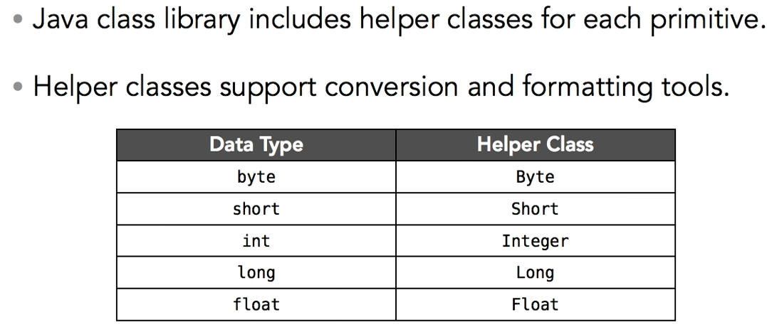

primitives and objects
double d = -1_234L * -1.25e-2f + -.25d;
Double D = new Double(d);
float f = D.floatValue();
long l = D.longValue();
short s = D.shortValue();
byte b = D.byteValue();
String str = D.toString() + '%';

Float F = new Float(f);
Long L = new Long(l);
Short S = new Short(s);
Byte B = new Byte(b);

MAX_VALUE
Byte.MAX_VALUE
Short.MAX_VALUE
Integer.MAX_VALUE
Long.MAX_VALUE
Float.MAX_VALUE
Double.MAX_VALUE

theory
import java.lang.Byte;
import java.lang.Integer;

public class Main {
public static void main(String[] args) {
byte b = -128;
b++;
java.lang.Byte B = new java.lang.Byte(b);

java.lang.Integer I = new java.lang.Integer(B.intValue());
I = null; B = null; //primitives cannot be set to null ! }
}

.toMethods of Helper class objects
Long L = new Long(128L);
L = (Long.MAX_VALUE % 127L);

byte b = L.byteValue();
short s = L.shortValue();
int i = -L.intValue(); //note the change of sign
long l = -L.longValue() / (2L+3);
float f = -L.floatValue() + -1.5E+20f;
double d= -L.doubleValue() * -1.5d;
String S = L.toString();

follow this code through
public class Main {
public static void main(String[] args) {
byte b; short s; int i; long l;
float f; double d;
Byte B; Short S; Integer I; Long L;
Float F; Double D; Double D2;

b = 127;
s = b;
i = s;
l = i + 123L;
f = b + s + i + l + 123L + -1.5f;
d = f + -2.75d;

B = b;
B = new Byte(b);
S = B.shortValue();
I = S.intValue();
L = I.longValue();
F = L.floatValue();
D = F.doubleValue();
D2 = B.doubleValue();
D *= D2;
}
}

byte b = Byte.MAX_VALUE; //127
Byte B1, B2, B3;

B1 = b;
B2 = new Byte(b);
B3 = B2.byteValue();

boolean bool = (B1 == B2) | (B2 == B3); //false
bool = B1.equals(B2) & B2.equals(B3); //true

upcasting during assignment
byte b; short s; int i; long l;
b = 1; // 1 is a byte
s = 1; // 1 is a byte upcast to a short
i = 127; //127 is a byte upcast to an integer
l = 1; // 1 is a byte upcast to a long
l = b; // the 'byte 1 value' is upcast to a long
l = 1L; // 1L is a long assigned to l

Float F;
F = 1; //ERROR cannot convert from int to Float
F = 1f; //OK
F = new Float(1); //1 is a byte
F = (float)1; //OK
F = new Float(1L); //OK
F = new Float(1d).floatValue(); //superfluous but the same

public class Main {
public static void main(String[] args) {
byte b = 127;
b++;
System.out.println(b);

if (b < 0){
System.out.println("Qué lástima!");
b--;
}

System.out.println("Now b=" + b);
}
}

java.math.BigDecimal
double d = 0.012;
d = d * 3; //0.036000000000000004
d *=2; //0.07200000000000001

BigDecimal D = new BigDecimal("0.012");
D = D.add(D).add(D);
D = D.multiply(new BigDecimal("3")); //this line has the same effect
d = D.doubleValue(); //0.108

Double D; String S;
D = new Double(127L); //means: take in any number (of lower type) and make a Double out of it
S = D.toString(); //means: turns the Double into a String
S = Double.toString(127f); //analogous

1.5 is a double
double d; float f;
d = 125.5; //125.5 is a double
d = 125.5d;
d = 125f; //ok
f = 125.5f;
f = (float)125.5;
f = 125.5; //ERROR cannot convert from double to float

integer devision
int i = 7;
i = i / 2; //3
i /= 2; //1

byte b; short s; int i; long l; float f; double d;

//widening
b = Byte.MAX_VALUE;
s = b;
i = s;
l = i;
f = l;
d = f;

//narrowing
b = (byte) s;
s = (short)i;
i = (int) l;
l = (long) f;
f = (float)d;

int i = 128; float f = (float)-.5;
i = i + 1;
i = (int)(i + f + 1L);
f = i + f;

float f = 7; int i = 2;
i = (int)f / i; // integer 3
f = f / i; //2.333
f = i / f; //1.2857
f = i; //3.0

i = i / 2; // 3
f = i / 2; // 3.0

.parse from String to numbers
int i = Integer.parseInt("12345");
Integer I = Integer.parseInt("12345");

float f = Float.parseFloat("-1.5f");
Double D = Double.parseDouble(".5d");

Float F = -1.5f;
Double D = null;
D = (double) F;
D = new Double(F);

S = NumberFormat.getNumberInstance().format(1_999_999.57f);
S = new String("Value: ") + S; // Value: 1,999,999.625

STRINGS AND STRING OPERATIONS

java.text.NumberFormat
import java.text.NumberFormat;
public class Main {
public static void main(String[] args) {

NumberFormat NF = NumberFormat.getNumberInstance();
System.out.println(NF);

boolean b = NF instanceof java.text.NumberFormat;
System.out.println(b);

String S = NF.format(1_000L);
System.out.println(S);

}
}

NumberFormat NF = NumberFormat.getCurrencyInstance();
String S = NF.format(1_000L);
or short:
S = NumberFormat.getPercentInstance().format(.75d);

import java.text.NumberFormat;
public class Main {
public static void main(String[] args) {

NumberFormat NF = NumberFormat.getCurrencyInstance();
String S = NF.format(1_000L);
System.out.println(S);

S = NumberFormat.getPercentInstance().format(.75d);
System.out.println(S);
}
}

public class Main {
public static void main(String[] args) {

StringBuilder SB = new StringBuilder();
SB.append("Abc");
SB.append("Def").append("Ghi");

System.out.println(SB);
}
}

public class Main {
public static void main(String[] args) {
String S,S1,S2="Xyz";
S1 = "Abc";
S = S1 + S2 + "!";
System.out.println(S); //enefficient

StringBuilder SB;
SB = new StringBuilder(S1);
SB.append(S2).append("!");
System.out.println(SB); //efficient

boolean b = S.equals(SB);
System.out.println(b); //false IDKY
}
}

comparison
public class Main {
public static void main(String[] args) {
String S,S1,S2="Xyz";
S1 = "Abc";
S = S1 + S2 + "!";
System.out.println(S); //enefficient

StringBuilder SB;
SB = new StringBuilder(S1);
SB.append(S2).append("!");
System.out.println(SB); //efficient

boolean b = S.equals(SB);
System.out.println(b);

char[] ac1 = S.toCharArray();
char[] ac2 = SB.toString().toCharArray();
b = ac1==ac2;
System.out.println(b); //false IDKY
System.out.println(ac1);
System.out.println(ac2);

b = S.equals(SB.toString());
System.out.println(b); //true

}
}

two ways to build strings
String S = "Abc" + "\u00D6" + new String("Xyz");
StringBuilder SB = new StringBuilder("Abc").append("\u00D6").append("Xyz");

the correct way to compare a String and a StringBuilder
b = S.equals(SB.toString())

public class Main {
public static void main(String[] args) {

String S = "Abc" + "\u00D6" + new String("Xyz");
StringBuilder SB = new StringBuilder("Abc").append("\u00D6").append("Xyz");
System.out.println(S+SB.toString());

boolean b;
b = S == SB.toString(); //false
b = S.equals(SB); //false
b = S.equals(SB.toString()); //true
System.out.println(b);
}
}

public class Main {
public static void main(String[] args) {
StringBuilder SB = new StringBuilder()
.append("Abc")
.append("\u00D6")
.append("Xyz");

System.out.println(SB);
}
}

public class Main {
public static void main(String[] args) {
String S1 = "Abc", S2;
S2 = S1;

boolean b = S1 == S2; //point to the same object
System.out.println(b); //true

S1 = S1 + S2; //AbcAbc
S2 = S1; //pointing to the same object
b = S1 == S2; //true
System.out.println(b); //true

S2 = S1+""; //AbcAbc
b = S1 == S2; //false because they now point to different (although equivelent) objects
System.out.println(b); //false

b = S1.equals(S2); //true
System.out.println(b);

S1 = S2.toUpperCase(); //ABCABC
b = S1.equalsIgnoreCase(S2); //true
System.out.println(b);
}
}

b = S1.equalsIgnoreCase(S2)

String S = null;
S = S + S;
S = S.concat(S);

i = S.length()

i = S.indexOf('a') //zero-based; -1 if missing
i = S.indexOf("bc")

S = S.substring(3) start
S = S.substring(0, 10) start, end

S = S.trim()

public class Main {
public static void main(String[] args) {
String S; int i;
S = new String("Abc");
i = S.length();
System.out.println(i);

i = S.indexOf("bc");
System.out.println(i);

i = S.indexOf('A'); //zero-based; -1 if missing
System.out.println(i);
}
}

public class Main {
public static void main(String[] args) {
String S; int i;
S = new String("Abc Def");

S = S.substring(4);
System.out.println(S);

S = S.substring(0, 2);
System.out.println(S);
}
}

public class Main {
public static void main(String[] args) {
String S;

S = "Abcdefghij".substring(2,5);
System.out.println(S);

int i = "Abcdefghij".substring(2,5).indexOf('d');
System.out.println(i);

Integer I = "Abcdefghij".substring(2,5).indexOf("de");
System.out.println(I);
}
}

public class Main {
public static void main(String[] args) {
String S;
S = " Abcdefghij ";

int i = S.length();
System.out.println(i);

S = S.trim();
i = S.length();
System.out.println(i);
}
}

practicing Scanner, StringBuilder
import java.util.Scanner;

public class Main {
public static void main(String[] args) {
String S;
StringBuilder SB;
Scanner SC;

SB = new StringBuilder("Beginning of the String\n");
SC = new Scanner(System.in);

for (int i=0;i<3;i++){
S = SC.nextLine();
S = (Integer.toString(i+1) + ". " + S + '\n');
SB.append(S);
};

SC.close();
S = SB.toString();
System.out.println(S + "End");
}
}

Scanner
Scanner SC = new java.util.Scanner(System.in);
S = SC.nextLine();
S = SC.nextLine();
SC.close();

public class Main {
static String S;
static Boolean B;
static Double D;

public static void main(String[] args) {
char[] a1, a2 = {}, a3 = {'A','b','c','d','e','f','g','h'};

//System.out.println(a1); //The local variable a1 may not have been initialized
System.out.println(a2);
System.out.println(a3);

a1 = a3;
System.out.println(a1);

String S = String.valueOf(a1);
System.out.println(S);

S = S.substring(1, S.length()-1); //zero-based
System.out.println(S); //bcdefg

int i = S.indexOf('b');
System.out.println(i); //0

a2 = S.toCharArray();
System.out.println(a2);

char c = a2[0];
System.out.println(c);

}
}

String S = new String("Abc");
S = S.substring(1, S.length()-1); //zero-based
int i = S.indexOf('b');

char c = 'c';
char[] a = {'A','b',c};
String S = String.valueOf(a); //"Abc"
a = S.toCharArray(); //[C@15db9742
c = a[0]; //'A' zero-based

public class Main {
public static void main(String[] args) {
char c = 'c';
char[] a = {'A','b',c};
String S = String.valueOf(a); //"Abc"
a = S.toCharArray(); //[C@15db9742
c = a[0]; //'A' zero-based
c = S.toCharArray()[0]; //same
String s = S.substring(0,1); //A
System.out.println(s+c);

S = s + c;
S = "Abc".substring(0,1) + "Abc".toCharArray()[0]; //same
System.out.println(S); //AA

boolean b = S instanceof String; //true
b = s.equals(String.valueOf(c)); //true
b = "A".equals(String.valueOf('A'));//same
System.out.println(b);
}
}

String s = "Abc".substring(0,1); //"A"
char c = "Abc".toCharArray()[0]; //'A'
boolean b = s.equals(String.valueOf(c)); //true

char c = 'c';
char[] a = {'A','b',c};
int i = a.length;

public class Main {
public static void main(String[] args) {
char c = '\u0024';
char[] a = {'A','b',c};
int i = a.length; //3

c = a[a.length - 1]; //'$'
String s = String.valueOf(a[2]);
s = String.valueOf(a).substring(a.length-1); //same

boolean b = s.equals(String.valueOf(c)); //true
System.out.println(s+c+b);
}
}

String s = "\u0024"; s = "$"; //same
char c = '\u0024'; c = '$'; //same
boolean b = s.equals(String.valueOf(c)); //true
b = "A".equals(String.valueOf('A')); //true

public class Main {
public static void main(String[] args) {
String S;
S = null;
System.out.println(S); //null

S = new String("\u0024\u0036.") + "9" + '9';
System.out.println(S); //"$6.99"

S = null;
System.out.println(S); //null
}
}

public class Main {
public static void main(String[] args) {
char c;
String S = null;
S = new String("Hello") + ' ' + "world!";

char[] a = S.toCharArray();
int n = a.length;

for (int i=0; i<n; i++){
c = a[i];
if (c == ' ') continue;
System.out.print(c);
S = new String("\t") + String.valueOf(i) + '\t' + c;
System.out.println(S);
};
}
}

StringBuilder
StringBuilder sb = new StringBuilder();
sb.append("This is ")
.append('a')
.append(new String(" sentence with "))
.append(6)
.append(" words.\nThis is a new line.");

sb.delete(46, sb.length());

String s = new String();
s = sb.toString(); //This is a sentence with 6 words.
System.out.println(sb); //This is a new

comparing char’s and Srtings
char c1='a', c2=c1;
String S1="Abc", S2 = new String("Abc");

boolean b = c1==c2; //true
b = S1==S2; //not safe, because not the same object
b = S1.equals(S2); //the correct way

b = S.toLowerCase().equals("Abc".toLowerCase())

char array
char[] a1 = {}, a2={'a','b','c'};
boolean b = a1 != a2; //true

String S = new String(a2);
b = S.equals("abc"); //true

String S1, S2 = "Abc", S3 = new String("Def");
S1 = S2 + S3 + "Ghi" + new String("Jkl") + -0L + (byte).75f; //"AbcDefGhiJkl00"

String S = ""; boolean b;
b = S instanceof java.lang.String;
b = "abc" instanceof String;
b = new String("abc") instanceof String;

char[] a = {'A','b','c'};
String S = new String(a); //"Abc"

a = S.toCharArray();
char c = a[2]; //'c'

boolean b = S instanceof String; //true
b = a instanceof char[]; //true

STRING FORMATTING

formatters
Locale LC = new java.util.Locale("da", "DK");
NumberFormat NF = java.text.NumberFormat.getCurrencyInstance(LC);
DateFormat DF = java.text.DateFormat.getDateInstance(DateFormat.FULL, LC);
DateTimeFormatter TF = java.time.format.DateTimeFormatter.ISO_DATE_TIME;
DateTimeFormatter FT = java.time.format.DateTimeFormatter.ofPattern("dd/MM/yyyy");
String S = NF.format(123456789);

import java.util.Locale;
import java.text.NumberFormat;
public class Main {
public static void main(String[] args) {
Locale LC = new Locale("da", "DK");
NumberFormat NF = NumberFormat.getNumberInstance(LC);
String S = NF.format(1_000_000.58);
System.out.println(S);

NF = NumberFormat.getCurrencyInstance();
S = NF.format(12.55f);
System.out.println(S);

NF = NumberFormat.getCurrencyInstance(LC);
S = NF.format(12.55f);
System.out.println(S);

NF = NumberFormat.getIntegerInstance();
S = NF.format(12.55f);
System.out.println(S);

boolean b = S instanceof String;
System.out.println(b); //true
}
}

Locale LC = new java.util.Locale("da", "DK");
NumberFormat NF = NumberFormat.getNumberInstance(LC);
String S = NF.format(1_000_000.58);

System.out.printf("%c%c %d", 65, 'a', 65); // Aa 65
System.out.printf("%c %10c %d %s %10.3f", 65, 'a', 65, "string", (float)1/3); // A a 65 string 0.333

ARRAYS

String[] sa = {"Jan", "Feb", "Mar"}; //[Ljava.lang.String;@15db9742
String S = sa[sa.length-1]; //zero-based
char c = S.toCharArray()[S.length()-1]; //zero-based
char[] ca = S.toCharArray();

public class Main {
public static void main(String[] args) {
System.out.println(args.length);

String[] sa = {"Jan","Feb","Mar"};

String S;
byte n = (byte) (sa.length - 1);
for(int i=n; i>=0; i--){
S = sa[i];
System.out.println(S);
}
}
}

String[] sa = "Jan,Feb,Mar".split(",");

String[] sa = {"","",""};
sa[0] = "new";

array indexing
char c = 'c';
char[] a = {'a','b',c};
c = a[2];

String S = "two";
String[] sa = {"zero", new String("one"), S};
S = sa[0];

public class Main {
public static void main(String[] args) {
char c = 'c';
char[] a = {'a','b',c};

char[] a2 = {a[0], a[1], a[2]}; //the objects get copied
a[0] = c;

for(int i = 0; i < a.length; i++){
System.out.println("" + i + ": " + a[i] + ' ' + a2[i]);
}
}}

array
byte[] ba = {-128, 0, 127}

String S1, S2 = "Xyz"; S1 = "Abc";
String[] AS = {S1, S2, "\u00D6ÄÜ", "\nß"};

array of primitive numbers
public class Main {
public static void main(String[] args){
int[] a = {10,20,30}; // mutable array
int[] y = function(a);
System.out.print("a[0]=" + a[0] + "\ny[0]=" + y[0]);

}
//DEFINE FUNCTIONS HERE (at the end of the Main class, after the main method)
static int[] function(int[] arr){ // the array is passes by copy but the references in that array are shared
arr[0]++; // changes the value in the passed in array
return arr;
}
}

mutable array (of primitive numbers)
int[] a = {10,20,30};
a[0]++;
a[1] = a[1] * a[2];
for(int n : a){n++; System.out.println(n);} // n++ doesnt change the values in the array
for(byte i=0; i < a.length; i++){a[i]++; System.out.println(a[i]);} // n++ changes the values

example
public class Main {
public static void main(String[] args){
int[] a = {10,20,30}; // mutable array
short ix = (short)(a.length - 1);
int[] y = function(a, (byte)ix); // (byte)int means cast the integer as byte
System.out.printf("a[%s]=" + a[ix] + "\ny[%s]=" + y[ix], ix, (byte)ix);

}
//DEFINE FUNCTIONS HERE (at the end of the Main class, after the main method)
static int[] function(int[] arr, byte ix){ // the array is passes by copy but the references in that array are shared
if(ix >= arr.length){throw (new ArrayIndexOutOfBoundsException("bad index"));}
arr[ix]++; // changes the value in the passed in array
return arr;
}
}

array of primitives
int x=3, y=2;
int[] a = {1, x*y, (byte)x, (short)y, (int)42.5d, new Integer(x+y), new Float("-1.5").intValue()};

for(int i=a.length-1; i>=0; i--){a[i]*=10;a[i]--;}
for(int i : a){System.out.println(i);}

array of strings
import java.lang.reflect.Array;
import java.util.Arrays;
char c = 'c';
String s = "Monday";
String[] a = {s+c, "Saturday", new String("Sunday"), String.valueOf(c)};
Arrays.sort(a);
for(int i=a.length-1; i>=0; i--){a[i]+="#";}
for(String temp : a){System.out.println(temp);}

boolean array
boolean b = true;
boolean[] a = {b, !b, b&b, b|b, b^b, b&&b, b||b, b==b, b!=b,
Boolean.parseBoolean("true"),
new Boolean(b),
String.valueOf(b).equals("true")};
for(boolean bool:a){System.out.println(bool);}
for(b:a){System.out.println(b);} //or like this (?)
b = a instanceof boolean[]; //true

sized array of primitive numbers
int[] arr = {10, 20, (int)30f, (byte)-40.d, new Integer(50)};
int[] a = new int[5];
for(int i=0; i<a.length; i++){a[i]=i;}
for(int i:a){System.out.println(i);}

sized array of char’s
char[] a = new char[10];
for(int i=0; i<a.length; i++){a[i]='A';}
for(char c:a){System.out.println(c);}
for(int i:a){System.out.println(i);} //65

sized array of strings
String[] a = new String[10];
for(int i=0; i<a.length; i++){a[i]="Abc";}
for(String s:a){System.out.println(s);}

sized array of complex number objects
Float[] a = new Float[10];
for(byte i=0; i<a.length; i++){a[i] = (float)i + -.5f;}
for(Float F:a){System.out.println(F.toString() + F.floatValue() + F.intValue());}

copy an array
int[] a1 = {10, 30, 20, 40, 60, (byte)70, (short)50d, (byte)128}; //128 will become -1
int[] a2 = new int[5];
System.arraycopy(a1, 3, a2, 0, 5);
Arrays.sort(a2);
for(int i:a2){System.out.println(i);}

copy an array of complex number-objects
Float[] a1 = {1f, .2f, (float)3, -4f, new Float(.5), 6.5f + (float)0.1, Float.valueOf("-.7")};
Float[] a2 = new Float[5];
System.arraycopy(a1, 2, a2, 0, a2.length);
Arrays.sort(a2);
for(double n:a2){System.out.println(n);} //double could be replaced with Float = OK

2D String array
String[][] mx = {{"A","C"},
{"B","D"}};
String s = mx[0][0];
for(String[] row:mx){for(String cell:row){System.out.println(cell);}}

2D array
int[][] mx1 = {{1,-4},
{2,-5},
{3,-6}};
int[][] mx2 = new int[3][2];
for(int i=0; i<3; i++){
java.util.Arrays.sort(mx1[i]);
for(int j=0; j<2; j++){
mx2[i][j]=mx1[i][j];}}

for(int[] row:mx2){
for(int value:row){
System.out.println(value);}}

length of a 2D array
char[][] a = new char[5][2];
int i = a.length; //5
i = a[i-1].length; //2

double[] a = {0,0,0};
for(byte i=0; i<a.length; i++){a[i] = i;}

array of primitives (bytes)
byte[] a = {0,1,127,-128};
Arrays.sort(a);
for(byte b:a){System.out.println(b);}

ArrayList
java.util.List<String> l = new java.util.ArrayList<String>();
List<Integer> L = new ArrayList<>();
l.add("One"); L.add(12345);

String[] a = {"Mon","Teus","Wed","Thu","Fri"};
String[] arr = new String[5];
Arrays.sort(a);
arr[0] = a[0]; //one pocket is copied
System.arraycopy(a, 1, arr, 1, 4); //the rest of the array is copied into a2

List<String> l = new ArrayList<>();
l.add(a[0]); l.add(arr[1]); l.add(a[2]+arr[2]);
l.remove(0);
String s = l.get(0);
int i = l.indexOf("NoSuchThing"); //-1
boolean b = l.get(0)==a[0] & l.get(0)==arr[0];

Iterator
List<String> l = new ArrayList<>();
boolean b = l.add("Zero");
b = l.add("One");
l.add(Boolean.toString(b));

Iterator<String> it = l.iterator();
boolean b = it.hasNext();
String v = it.next();

iterate through a List
List<String> l = new ArrayList<>(); l.add("zero"); l.add("one"); l.add("two");

//Java 8 iterator-method
l.forEach(System.out::println);

//Iterator
Iterator<String> it = l.iterator();
while(it.hasNext()){
String s = it.next();
System.out.println(s);}

//for each loop
for(String s:l){
s += '!';
System.out.println(s);}

//index loop
for(int i = 0; i<l.size(); i++){
String s = l.get(i);
System.out.println(s);}

HASHMAP

HashMap
java.util.Map<String, String> m = new java.util.HashMap<String, String>();
m.put("key", "value");
m.remove("key");
String s = m.get("key"); //returns null if the key is missing

Map<Float, Integer> M = new HashMap<>();
M.put(1.45f, 2); M.put((float)3.75, (int)4.1);
M.remove(3.75); //doesn't remove 3.75f because 3.75 is a decimal (no error though is raised)
int i = M.get(1.45f);

iterate through a HashMap’s keys
Map<Integer, String> m = new HashMap<>();
m.put(10, "ten"); m.put(20, "twenty"); m.put(30, "thirty");
m.put(10, "zehn");

Set<Integer> S = m.keySet();
for(int i:S){String s = m.get(i);}

Iterator<Integer> it = S.iterator();
while(it.hasNext()){
int i = it.next();
String s = m.get(i);}

iterate through a HashMap’s values
Map<Integer, String> m = new HashMap<>();
m.put(10, "ten"); m.put(20, "twenty"); m.put(30, "thirty");
m.put(10, "zehn"); m.remove(20); //update; remove an entry

Collection<String> C = m.values();
for(String s:C){System.out.println(s);}

Iterator<String> iter = C.iterator();
while(iter.hasNext()){String s = iter.next();}

DATES AND TIME

import java.util.Date;
import java.util.GregorianCalendar;
public class Main {
public static void main(String[] args) {

Date dt = new Date();
System.out.println(dt);

dt = new Date();

boolean b = dt instanceof Date;
System.out.println(b);

GregorianCalendar gc = new GregorianCalendar(2018, 0, 0); //Jan 1st
gc.add(GregorianCalendar.DATE, 1);
System.out.println(gc);
String S = gc.toString();
System.out.println(S);

dt = gc.getTime();
System.out.println(dt);
}
}

import java.util.Date;
import java.util.GregorianCalendar;
public class Main {
public static void main(String[] args) {

GregorianCalendar gc = new GregorianCalendar(2018, 0, 0); //Jan 1st
gc.add(GregorianCalendar.DATE, 1);
Date dt = gc.getTime();
System.out.println(dt);

dt = new Date(); //today's date and time
boolean b = dt.equals(gc.getTime());
System.out.println(b);
System.out.println(dt);
}
}

GregorianCalendar gc = new GregorianCalendar(2018, 0, 0); //Jan 1st
gc.add(GregorianCalendar.DATE, 1);
Date dt = gc.getTime();
boolean b = dt.equals(gc.getTime()); //true
analogous
java.util.GregorianCalendar GC; java.util.Date DT; boolean b;
GC= new java.util.GregorianCalendar(2018, 0, 0); //Jan 1st
GC.add(GregorianCalendar.HOUR, 1);
DT = GC.getTime();
b = DT.equals(GC.getTime()); //true

comprehensive demo
import java.util.Date;
import java.util.GregorianCalendar;
import java.util.Locale;
import java.text.DateFormat;
import java.text.NumberFormat;

public class Main {
public static void main(String[] args) {

GregorianCalendar GC; Date DT; DateFormat DF; NumberFormat NF; String S;

GC= new GregorianCalendar(2018, 0, 31); //January 1st
GC.add(GregorianCalendar.HOUR, 1);
DT = GC.getTime();
S = DT.toString();
System.out.println(S); //Wed Jan 31 01:00:00 CET 2018

DF = DateFormat.getDateInstance(); // note: no 'new' because no new instance is initiated
S = DF.format(DT);
System.out.println(S); //Jan 31, 2018

DF = DateFormat.getDateInstance(DateFormat.FULL);
S = DF.format(DT);
System.out.println(S); //Wednesday, January 31, 2018

Locale LC = new Locale("de", "GR");
DF = DateFormat.getDateInstance(DateFormat.FULL, LC);
DF = DateFormat.getDateInstance(0, LC); //same
S = DF.format(DT);
System.out.println(S); //Mittwoch, 31. Januar 2018

int i = DateFormat.FULL;
System.out.println(i); //0

NF = NumberFormat.getCurrencyInstance(LC);
S = NF.format(i);
System.out.println(S); //€ 0,00
}
}

Locale LC = new Locale("de", "GR");
DF = DateFormat.getDateInstance(DateFormat.FULL, LC);
S = DF.format(DT);

java.util.Date vs java.time.LocalDateTime
import java.util.Date;
import java.time.LocalDateTime;

public class Main {
public static void main(String[] args) {

Date DT = new Date();
System.out.println(DT);

LocalDateTime LDT = LocalDateTime.now(); //equivelent to new Date()
System.out.println(LDT);
}
}

Date DT = new java.util.Date();
LocalDateTime LD = java.time.LocalDateTime.now(); //equivelent to new Date()

new date format
import java.time.LocalDate;

public class Main {
public static void main(String[] args) {
LocalDate dt;

dt = LocalDate.of(2018, 12, 31); //2018-12-31
System.out.println(dt); //2018-12-31

String S = dt.toString();
System.out.println(dt); //2018-12-31
}
}

import java.time.LocalDate;
import java.time.format.DateTimeFormatter;

public class Main {
public static void main(String[] args) {
LocalDate DT;
DateTimeFormatter FT;
String S;

DT = LocalDate.of(2018, 12, 31);
System.out.println(DT);

FT = DateTimeFormatter.ISO_DATE;
System.out.println(FT);

S = FT.format(DT);
boolean b = FT.format(DT) instanceof String; //true
System.out.println(S + b); //2018-12-31true
}
}

LocalDate DT = LocalDate.of(2018, 12, 31);
DateTimeFormatter FT = DateTimeFormatter.ISO_DATE;
String S = FT.format(DT); //2018-12-31

LocalDate DT = LocalDate.of(2018, 1, 9);
DateTimeFormatter FT = DateTimeFormatter.ofPattern("dd/MM/yyyy");
String S = FT.format(DT); //09/01/2018

LOGICAL OPERATIONS

if statement
if(true){}
if(true) i=1;
if(!true){throw (new ArrayIndexOutOException("error"));}

if else statement
if(true){}else{}
if(!true){throw (new ArrayIndexOutOfBoundsException("error"));}else{S = null;}

if, else if, else
if(false){i=1;}
else if(!true){i=2;}
else{i=3;}

logical operators
b = true && false; //false
b = true & false; //false
b = true || false; //true
b = true | false; //true
b = !true; //false
b = true? true:false; //true

public class Main {
public static void main(String[] args) {

boolean b, b1=true, b2 = false;
b = b1 & b2; //false
b = b1 && b2; //same

b = b1 | b2; //true
b = b1 || b2; //same

b = !b; // b = not true
System.out.println(b);
}
}

Ternary
public class Main {
public static void main(String[] args) {
String S; boolean b;

S = (true || false) ? "yes" : "no";
System.out.println(S);

b = S.equals("yes");
int i = ((b == true) && (1>0)) ? 888 : 999;
System.out.println(i);

}
}

v = true ? “yes” : “no”

switch(i){case 1:i=1;break; case 2:i=2;break; default:i=3;}

public class Main {
public static void main(String[] args) {
int i;
i = 3;

switch (i) {
case 1:
i=1;
break;
case 2:
i=2;
break;
default:
i=3;
}

System.out.println(i);
}
}

public class Main {
public static void main(String[] args) {
String S;
S = "March";

switch (S) {
case "Jan":
S = "January";
break;
case "Feb":
S = "February";
break;
default:
S = "Misc";
}
System.out.println(S);
}
}

switch
int i; i = 3;

switch(i){
case 1:
i++; break;
case(2):
i+=2; break;
default:
i=0;
}

String s;
s = new String("Son");

switch(s){
case "Mon" : s = "Monday"; break;
case "Teu": s = "Teuseday"; break;
case"Wed":s="Teuseday";break;
default: s="other";}

LOOPS

public class Main {
public static void main(String[] args) {
char[] ac = new String("Abc").toCharArray();
System.out.println(ac);

for (char c : ac){System.out.println(c);};

String[] AS = {"Abc","xyz","123"};
System.out.println(AS);

for (String S : AS){System.out.println(S);};

Byte[] AB = {-128, 127};
for (Byte B : AB){System.out.println(B);};

byte[] ab = {-128, 127};
for (byte b : ab){System.out.println(b);};
}
}

for each loop
for (char c : ac){System.out.println(c);};
for (byte b : ab){System.out.println(b);};
for (String S : AS){System.out.println(S);};
for (Byte B : AB){System.out.println(B);};

public class Main {
public static void main(String[] args) {
String S1, S2 = "Xyz";
S1 = "Abc";
String[] AS = {S1, S2, "\u00D6ÄÜ", "\nß"};
System.out.println(AS);
for (String S : AS){System.out.println(S);;};
}
}

for each loop
for (int i : ai){System.out.println(i);};

for loop
for (int i = 0; i < 10; i++){System.out.println(i);};

public class Main {
public static void main(String[] args) {

int[] ai = {0,1,2,3,4,5,6,7,8,9};
for (int i : ai){System.out.println(i);};
//in effect the same as:
for (int i = 0; i < 10; i++){System.out.println(i);};
}
}

for each loop
int[] a = {1,2,3};
for(int i : a){System.out.println(i);}

char[] ca = {'a','b','c'};
for(char c : ca){System.out.println(c);}

String[] sa = {"Jan","Feb","Mar"};
for(String S : sa){System.out.println(S);}

public class Main {
public static void main(String[] args) {
String[] sa = {"Jan","Feb","Mar"};
for(String S : sa){
System.out.println(S);}

int[] a = {1,2,3};
for(int i : a){System.out.println(i);}

char[] ca = {'a','b','c'};
for(char c : ca){System.out.println(c);}

}
}

while loop
while(true){break;}

int k = 0;
while(k < 10){k++;}

public class Main {
public static void main(String[] args) {
int k = 0;
while(k < 10){
k++;
System.out.println(k);}

System.out.println("done");
}
}

public class Main {
public static void main(String[] args) {

char c;
char[] a = {'a','b','c'};

int i = a.length;
while(i > 0){
i--;
c = a[i];
System.out.println(c + Integer.toString(i));}

System.out.println("done");
}
}

public class Main {
public static void main(String[] args) {

int k;
k = 0;

while(k<10){
k++;
System.out.println(k);
}

do{
k--;
System.out.println(k);
} while(k!=0);

}
}

do while loop
while(true){break;}
do{break;}while(true);

public class Main {
static String S; // null
public static void main(String[] args) {
S += 'c'; // "nullc"
method();
}

static void method(){
System.out.println(S); // "nullc"
}
}

for loop with a predefined i
int i;
for(i=0; i<n; i+=2){
String s1 = a[i], s2 = a[i+1];
temp = function(s1, s2, '+');
result += temp;
}

ERRORS

raise an Exception
if(!true){throw (new ArrayIndexOutOException("error"));}

public class Main {
public static void main(String[] args) {

String S; char[] a; char c; int i;

S = new String("Abc");
a = S.toCharArray();
i = a.length;

try {
c = a[i];
System.out.println(c);
} catch (Exception err) {
err.printStackTrace();
S = err.toString();
System.out.println(S);

S = err.getMessage();
System.out.println(S);
}

System.out.println("OK");
}
}

public class Main {
public static void main(String[] args) {
char c; char[] a = {'a','b','c'}; String S = ""; StringBuilder SB = new StringBuilder("!!!");
try{c = a[9];} catch (Exception err){SB.append(err.toString());}
try{c = a[9];} catch (ArrayIndexOutOfBoundsException err){SB.append(err.toString());} catch (StringIndexOutOfBoundsException err){SB.append(err.toString());}
System.out.println(SB.toString() + "\nend");
}
}

char c; char[] a = {'a','b','c'}; String S = "";
try{c = a[9];} catch (Exception err){S = err.toString();}

public class Main {
public static void main(String[] args) {
char c; char[] a; String S;
c = '\u0061';
S = new String("br") + c;
a = S.toCharArray();
S = a.toString(); // "[C@15db9742"
S = String.valueOf(a); //"bra"
System.out.println(S);

try{
c = a[a.length-1]; //ArrayIndexOutOfBoundsException can occur here
S = S.substring(S.length()+1); //StringIndexOutOfBoundsException can occur here
}
catch (ArrayIndexOutOfBoundsException err){
System.out.println("array index error");}
catch (StringIndexOutOfBoundsException err){
System.out.println("string index error");
}

System.out.println("end");
}
}

try{…;}
catch (ArrayIndexOutOfBoundsException err){…;}
catch (StringIndexOutOfBoundsException err){…;}

try{throw (new Exception("error"));} catch(Exception err){System.out.println(err.getMessage());}

public class Main {
public static void main(String[] args) {
String S = null;

try {throw (new ArrayIndexOutOfBoundsException("error"));} catch(ArrayIndexOutOfBoundsException err){S = err.getMessage();}
System.out.println(S);
if(true){}
if(!true){throw (new ArrayIndexOutOfBoundsException("error"));}

System.out.println("end");
}
}

catch an error, print a message and then throw that error
catch(java.lang.NumberFormatException err){System.out.println(err.getMessage()); throw err;}

try{float f=1/0;}catch(Exception err){return;}

catch an error within a loop
float f = 0;
try{for(int i=6; i>=0; i-=2){f=1/i;}}catch(Exception err){return;} //catches error when i==0

FUNCTION - CUSTOM METHODS

static void method(){;}

In Java variables are always passed by copy i.e. by val

public class Main {
public static void main(String[] args){
int i, output;
i = 0;
output = method(i);
System.out.println(output); //1
System.out.println(i); //0 - not changed

}
//DEFINE FUNCTIONS HERE (at the end of the Main class, after the main method)
static int method(int arg){
arg++;
return arg;}
}

Passing primitive values into a function – always by copy
public class Main {
public static void main(String[] args){
int a,b;
a = 1;
b = function(a); // a will not be changed
System.out.println("a="+a+"\nb="+b);

}
//DEFINE FUNCTIONS HERE (at the end of the Main class, after the main method)
static int function(int arg){ //arg is passed in by copy
arg++;
return arg;
}
}

public class Main {
public static void main(String[] args){
java.lang.Integer a,b;
a = new Integer(10);
b = function(a); // a will not be changed
System.out.println("a="+a+"\nb="+b);

}
//DEFINE FUNCTIONS HERE (at the end of the Main class, after the main method)
static Integer function(Integer arg){ //arg is passed in by copy
arg++;
return arg;
}
}

passing a String into a function (String is an immutable object)
public class Main {
public static void main(String[] args){
String s1 = new String("Abc"), s2; //same as: String s = "Abc"
s2 = function(s1);
System.out.println("s1 = " + s1 + "\ns2 = " + s2); //s1 is unchanged
}
//DEFINE FUNCTIONS HERE (at the end of the Main class, after the main method)
static String function(String arg){
arg += "Xyz";
return arg;
}
}

mutable objects are passed into a function by ref (i.e. shared)
public class Main {
public static void main(String[] args){
StringBuilder SB = new StringBuilder();
SB.append("Line1\n");
StringBuilder SB2 = function(SB);

String S1 = SB.toString();
String S2 = SB2.toString();

System.out.println(S1);
System.out.println(S2);

}
//DEFINE FUNCTIONS HERE (at the end of the Main class, after the main method)
static StringBuilder function(StringBuilder arg){
arg.append("Line2\n");
return arg;}
}

public class Main {
public static void main(String[] args) {
method();
}

static void method(){
System.out.println("<static void method in action>");
}
}

public class Main {
private static String S1;
public static String S2;
static String S3;
public static void main(String[] args) {
String S = "string";
System.out.println(S+S1+S2+S3);
method();
}

static void method(){
S1 = S2 = S3 = "Abc";
System.out.println(S1+S2+S3);
}
}

static void method(String arg1, int arg2, char[] arg3){System.out.println(arg1 + arg2 + arg3);}

public class Main {
public static void main(String[] args) {
char[] a = {'a','b','c'};
method("string", 999, a);
}
static void method(String arg1, int arg2, char[] arg3){
System.out.println(arg1 + arg2 + arg3);
for(char c : arg3){System.out.println(c);}
}
}

non-void method with arguments
static String method(String[] arg1, String arg2, int arg3){
String result = arg1[0] + arg2 + arg3;
return result;}

public class Main {
static String S;
public static void main(String[] args) {
char[] a = {'a','b','c'};
String[] sa = {"Jan","Feb","Mar"};

method1(); //void with no arguments
method2(method3(), sa[2], a); //void with arguments
int output = method3(); //return with no arguments
System.out.println(output);
String Output = method4(sa, S, output); //return with arguments
System.out.println(Output);
}

static void method1(){
S = "this is method 1";
System.out.println(S);}

static void method2(int arg1, String arg2, char[] arg3){
System.out.println(arg2 + arg1 + arg3[0]);}

static int method3(){
int i = -999;
return i;}

static String method4(String[] arg1, String arg2, int arg3){
String result = arg1[0] + arg2 + arg3;
return result;}
}

void methods overloading
public class Main {
static byte b;
public static void main(String[] args) {
//MAIN
method1();
System.out.println(b);

method1(255);
System.out.println(b);

method1(b);
method1((byte) 255); //same
System.out.println(b);

method1(10, 20);
System.out.println(b);

method1(b, (short) 2);
System.out.println(b);
}

//DEFINE FUNCTIONS HERE
static void method1(){
b = 0;}

static void method1(int arg){
b = 1;}

static void method1(byte arg){
b = -1;}

static void method1(int arg1, int arg2){
b = 2;}

static void method1(byte arg1, short arg2){
b = -2;}
}

public class Main {
static byte b;
public static void main(String[] args) {
//MAIN
int output;

output = method(1,2,3);
System.out.println(output);

output = method(1, (short) 2, (byte) 3);
System.out.println(output);

int[] a = {1,2,3};
output = method(a);
System.out.println(output);

output = method("one", "two", "three");
System.out.println(output);
}

//DEFINE FUNCTIONS HERE
static int method(int arg1, int arg2, int arg3){
byte result = 3;
return result;
}

static byte method(int arg1, short arg2, byte arg3){
byte result = -3;
return result;
}

static byte method(int[] args){
byte result = 125;
return result;
}

static short method(String ... args){
short result = -125;
return result;
}
}

public class Main {
static byte b;
public static void main(String[] args) {
//MAIN
int output;

output = method(1,2,3);
System.out.println(output);

output = method(1, (short) 2, (byte) 3);
System.out.println(output);

int[] a = {1,2,3};

output = method(a);
System.out.println(output);
}

//DEFINE FUNCTIONS HERE
static int method(int arg1, int arg2, int arg3){
byte result = 3;
return result;
}

static byte method(int arg1, short arg2, byte arg3){
byte result = -3;
return result;
}

static short method(int ... args){
short result = -125;
return result;
}
}

public class Main {
static byte b;
public static void main(String[] args) {
//MAIN
String Output;
int[] intarray = {10,20,30,40};
byte[] ba = {10,20,30,40};

Output = method(1,2,3,4,5);
System.out.println(Output);

Output = method(intarray);
System.out.println(Output);

Output = method(ba);
System.out.println(Output);

Output = method(-999, (byte) 127, 'c', "String", intarray, ba);
System.out.println(Output);

}

//DEFINE FUNCTIONS HERE
static String method(int ... args){ //in effect same as int[]
String S = "Ellipsis";
return(S);
}

static String method(byte[] args){ //in effect same as byte ...
String S = "byte[]";
return(S);
}

static String method(int arg1, byte arg2, char arg3, String arg4, int[] arg5, byte ... arg6){
String S = "result:" + arg1 + arg2 + arg3 + arg4 + arg5 + arg6;
return(S);
}
}

static String method(int arg1, byte arg2, char arg3, String arg4, int[] arg5, byte ... arg6){
String S = "result:" + arg1 + arg2 + arg3 + arg4 + arg5 + arg6;
return(S);
StringOutput = method(-999, (byte) 127, 'c', "String", intarray, ba);

comprehensive exercise
import java.util.Scanner;

public class Main {
static byte b;
public static void main(String[] args) {
//MAIN
double d1 = getInput("Enter value 1:");
System.out.println(d1);

}

//DEFINE FUNCTIONS HERE
static double getInput(String prompt){
int i = prompt.length();
prompt = prompt.substring(i-1).equals(" ") ? prompt : prompt+" ";
System.out.print(prompt);
Scanner SC = new Scanner(System.in);
String S = SC.nextLine();
SC.close();
double d = 0;
try{d = Double.parseDouble(S);}
catch(java.lang.NumberFormatException err){System.out.println(err.getMessage()); throw err;}
return d;
}

}

public class Main {
public static void main(String[] args){
//MAIN
method();
method(123);
int[] a = {1,2,3};
method(a);
method("arg1","arg2","arg3");
}

//DEFINE FUNCTIONS HERE (at the end of the Main class, after the main method)
static void method(){;}
static void method(int arg){;}
static void method(int[] args){;}
static void method(String ... args){System.out.println(args[0]);;}
}

public class Main {
public static void main(String[] args){
int i = Integer.MIN_VALUE;
int[] a = {i,i+1};

i = method();
i = method(i);
i = method(a);
i = method("arg1","arg2","arg3");

}
//DEFINE FUNCTIONS HERE (at the end of the Main class, after the main method)
static int method(){return 1;}
static int method(int arg){return 2;}
static int method(int[] args){return 3;}
static int method(String ... args){return args.length;}
}

END

